Mission of the Department
To establish learning ambience for ushering in computer engineering professionals in core and multidisciplinary area by developing Problemsolving skills through emerging technologies.

Session 2025-2026

Vision: Dream of where you want. | Mission: Means to achieve Vision

Program Educational Objectives of the program (PEO): (broad statements that describe the professional and career accomplishments)
PEO1 | Preparation | P: Preparation | Pep-CL abbreviation pronounce as Pep-si-lL easy to recall
PEO2 | Core Competence | E: Environment  (Learning Environment) | Pep-CL abbreviation pronounce as Pep-si-lL easy to recall
PEO3 | Breadth | P: Professionalism | Pep-CL abbreviation pronounce as Pep-si-lL easy to recall
PEO4 | Professionalism | C: Core Competence | Pep-CL abbreviation pronounce as Pep-si-lL easy to recall
PEO5 | Learning  Environment | L: Breadth (Learning in diverse areas) | Pep-CL abbreviation pronounce as Pep-si-lL easy to recall

Program Outcomes (PO): (statements that describe what a student should be able to do and know by the end of a program)
Keywords of POs:
Engineering knowledge, Problem analysis, Design/development of solutions, Conduct Investigations of Complex Problems, Engineering Tool Usage, The Engineer and The World, Ethics, Individual and Collaborative Team work, Communication, Project Management and Finance, Life-Long Learning

PSO Keywords: Cutting edge technologies, Research

“I am an engineer, and I know how to apply engineering knowledge to investigate, analyse and design solutions to complex problems using tools for entire world following all ethics in a collaborative way with proper management skills throughout my life.” to contribute to the development of cutting-edge technologies and Research.

Integrity: I will adhere to the Laboratory Code of Conduct and ethics in its entirety.

Name and Signature of Student and Date
(Signature and Date in Handwritten)

Mission of the Department
To establish learning ambience for ushering in computer engineering professionals in core and multidisciplinary area by developing Problemsolving skills through emerging technologies.

Session | 2025-26 (ODD) |  | Course Name | Operating System Lab
Semester | 5 |  | Course Code | 23IOT1504
Roll No | 37 |  | Name of Student | Dhanashri Raut
Practical  Number |  | 09
Course  Outcome |  | - Understand Computer System Configuration and Simulate system resources efficiently using Linux Commands (CO1)  - Analyse operating system functionalities utilizing system calls, thread programming and process scheduling algorithms (CO2)  - Apply Synchronization primitives to implement a Deadlock-free solution(CO3)  - Simulate Disk scheduling, Memory allocation, File allocation, page replacement algorithms (CO4)
Aim |  | Simulate All File Allocation Stratergies- A. Sequential  - Indexed  - Linked
Problem
Definition
Theory (100 words) |  | File allocation refers to the method by which operating systems allocate disk space to files. Different strategies offer trade-offs between efficiency, fragmentation, and access speed.  Three Main Allocation Strategies:  - Sequential Allocation o Files are stored in contiguous disk blocks o Requires pre-allocation of space  - Fast sequential access but suffers from external fragmentation  - Indexed Allocation o Uses an index block containing pointers to all file blocks o Supports both sequential and direct access  - Eliminates external fragmentation but has index block overhead  - Linked Allocation o Each block contains a pointer to the next block  - No external fragmentation  - Sequential access only, with pointer storage overhead

Mission of the Department
To establish learning ambience for ushering in computer engineering professionals in core and multidisciplinary area by developing Problemsolving skills through emerging technologies.

Procedure and  Execution  (100  Words) | Step for Implementation:  Sequential Allocation Implementation Algorithm:  - Search for contiguous free blocks of required size  - If found, allocate all blocks to the file  - Mark blocks with file ID  Indexed Allocation Implementation Algorithm:  - Find free block for index table  - Find scattered free blocks for file data  - Store file ID in index block and data blocks  Linked Allocation Implementation Algorithm:  - Find any free blocks (need not be contiguous)  - Allocate blocks and mark with file ID  - Maintain logical linking through data structure
Procedure and  Execution  (100  Words) | Code:  #include <stdio.h>  #include <stdlib.h>  #include <string.h>  #define DISK_SIZE 50  #define MAX_FILES 5  int disk[DISK_SIZE];  int file_count = 0;  void init_disk() { for(int i = 0; i < DISK_SIZE; i++) { disk[i] = -1;  }  }  void show_disk() { printf("\nDisk: "); for(int i = 0; i < DISK_SIZE; i++) { if(disk[i] == -1) printf(". "); else printf("%d ", disk[i]); }

Mission of the Department
To establish learning ambience for ushering in computer engineering professionals in core and multidisciplinary area by developing Problemsolving skills through emerging technologies.

printf("\n");
}

void sequential() { char name[20]; int size, start = -1, count = 0;

printf("File name: "); scanf("%s", name); printf("Size (blocks): ");
scanf("%d", &size);

for(int i = 0; i < DISK_SIZE; i++) {
if(disk[i] == -1) { if(count == 0) start = i; count++; if(count == size) break;
} else { count = 0;
}
}

if(count < size) { printf("Not enough contiguous space!\n"); return;
}

for(int i = start; i < start + size; i++) { disk[i] = file_count;
}

printf("File '%s' allocated at block %d (ID: %d)\n", name, start, file_count); file_count++;
}

void indexed() { char name[20];
int size, index_block = -1;
int blocks[10], block_count = 0;

printf("File name: "); scanf("%s", name); printf("Size (blocks): ");

Mission of the Department
To establish learning ambience for ushering in computer engineering professionals in core and multidisciplinary area by developing Problemsolving skills through emerging technologies.

scanf("%d", &size);

for(int i = 0; i < DISK_SIZE; i++) {
if(disk[i] == -1) { index_block = i;
break;
}
}

if(index_block == -1) { printf("No space for index block!\n"); return;
}

for(int i = 0; i < DISK_SIZE && block_count < size; i++) {
if(disk[i] == -1 && i != index_block) { blocks[block_count++] = i;
}
}

if(block_count < size) { printf("Not enough data blocks!\n"); return;
}

disk[index_block] = file_count; for(int i = 0; i < size; i++) {
disk[blocks[i]] = file_count;
}

printf("File '%s' allocated (ID: %d), Index block: %d\n", name, file_count, index_block); file_count++;
}

void linked() { char name[20]; int size; int blocks[10], block_count = 0;

printf("File name: "); scanf("%s", name); printf("Size (blocks): ");

Mission of the Department
To establish learning ambience for ushering in computer engineering professionals in core and multidisciplinary area by developing Problemsolving skills through emerging technologies.

scanf("%d", &size);

for(int i = 0; i < DISK_SIZE && block_count < size; i++) { if(disk[i] == -1) { blocks[block_count++] = i;
}
}

if(block_count < size) { printf("Not enough space!\n"); return;
}

for(int i = 0; i < size; i++) {
disk[blocks[i]] = file_count;
}

printf("File '%s' allocated (ID: %d), Blocks: ", name, file_count); for(int i = 0; i < size; i++) { printf("%d", blocks[i]); if(i < size-1) printf("->");
}
printf("\n"); file_count++;
}

void delete_file() { int id; printf("File ID to delete: ");
scanf("%d", &id);

int found = 0; for(int i = 0; i < DISK_SIZE; i++) {
if(disk[i] == id) { disk[i] = -1; found = 1;
}
}

if(found) printf("File %d deleted!\n", id); else printf("File not found!\n");
}

Department of Computer Technology

Vision of the Department
To be a well-known centre for pursuing computer education through innovative pedagogy, value-based education and industry collaboration.

Mission of the Department
To establish learning ambience for ushering in computer engineering professionals in core and multidisciplinary area by developing Problemsolving skills through emerging technologies.

int main() { int choice;
init_disk();

printf("=== Simple File Allocation Simulator ===\n");

while(1) { printf("\n1. Sequential\n2. Indexed\n3. Linked\n4. Show Disk\n5. Delete File\n6. Exit\nChoice: ");
scanf("%d", &choice);

switch(choice) { case 1: sequential(); break; case 2: indexed(); break; case 3: linked(); break; case 4: show_disk(); break; case 5: delete_file(); break;
case 6: exit(0); default: printf("Invalid choice!\n");
}
}

return 0;
}

Department of Computer Technology

Vision of the Department
To be a well-known centre for pursuing computer education through innovative pedagogy, value-based education and industry collaboration.

Mission of the Department
To establish learning ambience for ushering in computer engineering professionals in core and multidisciplinary area by developing Problemsolving skills through emerging technologies.

Output:

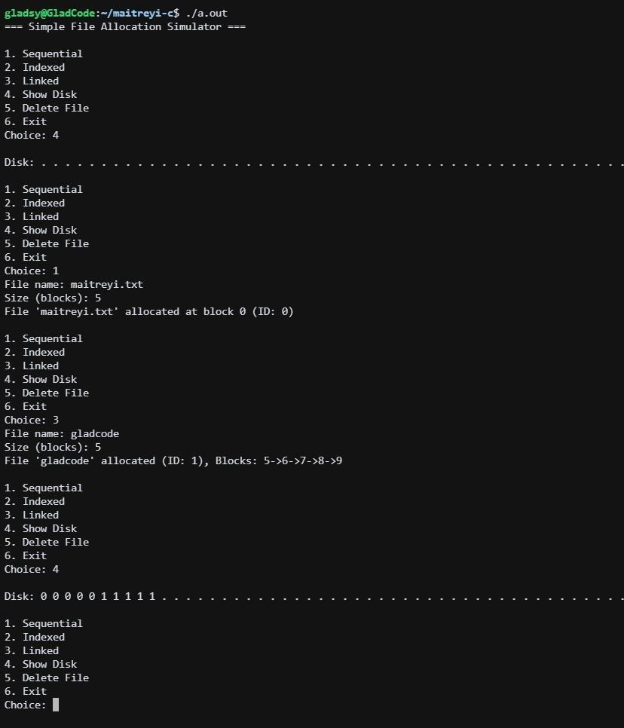
Output  Analysis | Scenario 1: Sequential Allocation  - Contiguous blocks 0-4 allocated  - Shows clean contiguous allocation pattern  Scenario 2: Indexed Allocation  - Block 5 serves as index block  - Data blocks scattered but linked through indexScenario 3: Linked Allocation  - Blocks linked in sequence 6→7→8→9  - Visual representation shows scattered allocation  Fragmentation Analysis: Sequential:  - External fragmentation evident as files are deleted
Department of Computer Technology

Vision of the Department
To be a well-known centre for pursuing computer education through innovative pedagogy, value-based education and industry collaboration.

Mission of the Department
To establish learning ambience for ushering in computer engineering professionals in core and multidisciplinary area by developing Problemsolving skills through emerging technologies.

- Large contiguous spaces become fragmented Indexed/Linked:
- No external fragmentation
- Efficient space utilization

Performance Characteristics:

Strategy | Access Time | Fragmentation | Space  Overhead
Sequential | Fast sequential | High external | None
Indexed | Direct access | None | Index block
Linked | Sequential only | None | Pointers

Link of student Github profile where lab assignment has been uploaded | https://github.com/24030192-lab/-OS-Practicals
Conclusion | This program effectively demonstrates:  - How different allocation strategies manage disk space  - The impact of allocation methods on disk fragmentation  - The relationship between allocation strategy and file access patterns  - Practical implementation of operating system concepts  This program serves as an excellent educational tool for understanding fundamental file system concepts and the practical implications of different allocation strategies in operating systems.

NAAC A++
Ph.: 07104-237919, 234623, 329249, 329250 Fax: 07104-232376, Website: www.ycce.edu
Department of Computer Technology

Vision of the Department
To be a well-known centre for pursuing computer education through innovative pedagogy, value-based education and industry collaboration.

Mission of the Department
To establish learning ambience for ushering in computer engineering professionals in core and multidisciplinary area by developing Problemsolving skills through emerging technologies.

Plag  Report (Similarity  index < 12%) | 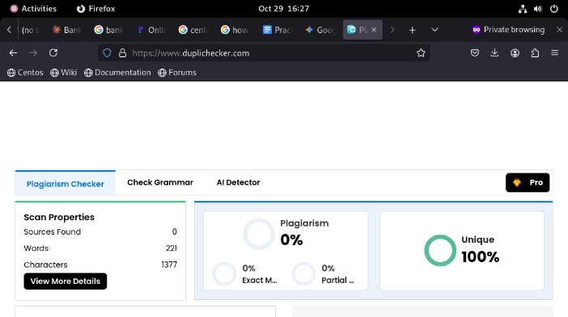
Date | 29/10/25

